As of 22 Nov 2021

Dominique Laurier

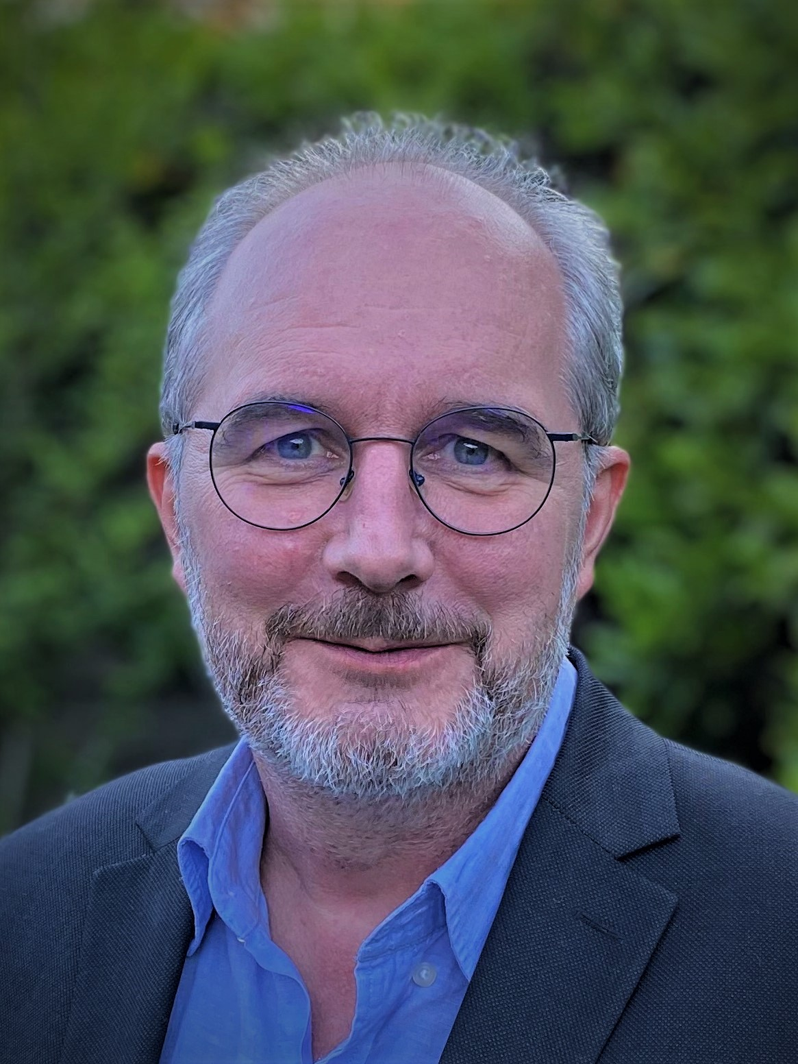 | Dominique Laurier holds a PhD degree in Biomathematics from the University of Paris-Diderot in Paris, France. He studied nutrition, epidemiology and biostatistics. He was employed for some years as a lecturer in biostatistics at the University of Paris-Diderot, during which time he worked in the field of cardiovascular disease epidemiology. He joined the epidemiological unit of the French Institute for Radiological Protection and Nuclear Safety (IRSN) in 1995. He is currently Head of a research Department on the Biological and Health Effects of Low-Dose Radiation Exposure at IRSN.

D. Laurier has 25 years of experience in the field of radiation epidemiology, particularly in the assessment of long-term health risks associated with exposure to low-dose and low-dose-rate ionising radiation. His particular interests in the field are dose-risk modelling for cancer and non-cancer diseases, quantification of risks associated with radon and other internal contamination, effects of childhood exposure, health consequences of nuclear accidents and calculation of radiation detriment.

D. Laurier has participated in numerous international collaborative research projects (Alpha-risk, DoReMi, EPI-CT, CURE, Co-Cher, Shamisen, INWORKS, PUMA...). He is author or co-author of more than 170 articles in peer-reviewed scientific journals.

D. Laurier has participated to several national of international expert groups, notably for the World Health Organization (WHO) or the International Agency for Research on Cancer (IARC). He is a member of the French delegation to the United Nations Scientific Committee on the Effects of Atomic Radiation (UNSCEAR) since 2019 and is the French representative to UNSCEAR since 2021. He is the Chair of the Nuclear Energy Agency (NEA) High-Level Group on Low Dose Research (HLG-LDR) since 2020.

D. Laurier involvement with the International Commission on Radiological Protection began in 2006, as a member of a Task Group on cancer risks associated with alpha emitters. He became a member of ICRP Committee 1 in 2013 and Secretary of that Committee in 2016. He has been a member of the ICRP Main Commission since July 2017, and Chair of Committee 1 since July 2021.

